**E-FARMING**

*A*

*Project Report*

*Submitted in partial fulfilment of the*

*Requirements for the award of the Degree of*

**BACHELOR OF ENGINEERING**

IN

**INFORMATION TECHNOLOGY**

By

**P. JACOB (1602-17-737-013)**

**C. PRAVEEN (1602-17-737-025)**

**K.RAJ KUMAR (1602-17-737-027)**

*Under the guidance of*

**Mr. DAVID RAJU**

**Assistant Professor**



**Department of Information Technology**

**Vasavi College of Engineering (Autonomous)**

**(Affiliated to Osmania University) Ibrahimbagh, Hyderabad-31**

**2019-2020**

**Vasavi College of Engineering (Autonomous)**

**(Affiliated to Osmania University) Hyderabad-500 031**

**Department of Information Technology**



**DECLARATION BY THE CANDIDATE**

I, **P.JACOB, C.PRAVEEN, K.RAJ KUMAR** bearing hall ticket number **1602-17-737-013, 1602-17-737-025, 1602-17-737-027** hereby declare that the project report entitled **“E-FARMING”** under the guidance of **N.DAVID RAJU**, Assistant Professor, Department of Information Technology, Vasavi College of Engineering, Hyderabad, is submitted in partial fulfilment of the requirement for the award of the degree of **Bachelor of Engineering** in **Information Technology.**

This is a record of bona fide work carried out by me and the results embodied in this project report have not been submitted to any other university or institute for the award of any other degree or diploma.

**P. JACOB (1602-17-737-013)**

**C.PRAVEEN (1602-17-737-025)**

**K.RAJ KUMAR (1602-17-737-027)**

**Vasavi College of Engineering (Autonomous)**

**(Affiliated to Osmania University) Hyderabad-500 031**

**Department of Information Technology**



**BONAFIDE CERTIFICATE**

Thisis to certify that the project entitled “**E-FARMING”** being submitted by **P.JACOB, C.PRAVEEN, K.RAJ KUMAR** bearing **1602-17-737-013, 1602-17-737-025, 1602-17-737-027** in partial fulfilment of the requirements for the award of the degree of Bachelor of Engineering in Information Technology is a record of bona fide work carried out by him/her under my guidance.

**David Raju Dr. K. Ram Mohan Rao**

**Assistant Professor HOD , IT**

**Internal Guide**

**ACKNOWLEDGEMENT**

The satisfaction that accompanies that the successful completion of the project would not have been possible without the kind support and help of many individuals. We would like to extend my sincere thanks to all of them.

We would like to take the opportunity to express our humble gratitude to David Raju Sir under whom we executed this project.

We would also use this opportunity to thank our senior Shiva Kumar (1602-16-737-104). We are grateful to his guidance, and constructive suggestions that helped us in the preparation of this project. His constant guidance and willingness to share his vast knowledge made us understand this project and its manifestations in great depths and helped us to complete the assigned tasks. We would like to thank all faculty members and staff of the Department of Information Technology for their generous help in various ways for the completion of this project.

Finally, yet importantly we would like to express our heartfelt thanks to our HOD Dr. K. Ram Mohan Rao Sir and classmates for their help and wishes for the successful completion of this project.

# ABSTRACT

The main objective of this project is building a website which will help Indian farmers to

make the effective cultivation by providing up-to-date information and make a path to

earn more money from Indian villages by selling their products to different cities online.

Here farmers can gain a lot of information like, what crop to grow in what season, what

are the preventive measures to crop diseases and how to overcome a particular crop

disease etc. Farmers can also buy seeds, fertilizers and pesticides online. If they have

computer knowledge they can directly register in the site and can start using I otherwise

they can contact person set by us in the village and register to the site. Once farmers get

used to it, it would be quite beneficial and can increase the average income.

The sole purpose of this project is to help Indian farmers to increase their average annual

income at least to some extent. We also try to educate them a bit and sharpen their minds

agriculturally by providing fruitful tips or suggestions.

**TABLE OF CONTENTS**

1.Introduction……………………………………………………………………………………….8

1.1 App title and Description……………………………………………………….8

1.2 Motivation……………………………………………………………………………..8

1.3 Objectives……………………………………………………………………………….8

1.4 Scope……………………………………………………………………………………..8

2.Software Analysis………………………………………………………………………………..9

2.1 General Description………………………………………………………………..9

2.1.1 Product Overview……………………………………….………......9

2.1.2 User Characteristics…….…………………………..……………….9

2.1.3 General Characteristics……………………………………………..9

2.2 System Requirements…………………….……………………………………….9

2.2.1 Hardware Requirements…….………………………………………9

2.2.2 Software Requirements………..…………………………………….10

2.3 System Features………………………………………………………………………10

2.4 Design Features……………………………………………………………………….10

3.Related Work……………………………………………………………………………………….10

4.System Design.…………………………………………………………………………………....11

4.1Architecture and Technology used………………………………………..…11

4.2 Design……………………………………………………………………………………..11

1.Use-Case Diagram……………………………………………………………..12

2.Class Diagram……………………………………………………………………13

3.Sequence Diagram…………………………………………………………….14

5. Implementation…………………………………………………………………………………..15

6.Results…………………………………………………………………………………………………27

7.Testing………………………….……………………………………………………………………..40

8.Conclusion and Future Scope………………………………….….…………………….. 41

9.References…………………………………………………………………………………………..42

**1.INTRODUCTION**

* 1. **App title and description**

E-Farming is a platform where farmers can learn various methods of Agricultural practices. Farmers can post queries related to various agricultural issues like what crop to grow in a season, what pesticide or fertilizer to use for a specific disease etc. Anyone who has an idea or solution to a particular question can reply to it and we as admins will give a solution which is of highest priority. In this way, Indian farmers can learn some tips and increase their annual production.

* 1. **Motivation**

E-Farming builds a community with the peers, it creates an opportunity to explore and enhance farming skills. Farmers can discuss, compare and improve their agricultural practices or strategies. It is to educate poor farmers to some extent and try and help them to increase overall annual production.

* 1. **Objectives**

Design an application that creates communication medium for the farmers who wants to know more about the new farming techniques.

1. Farmers can post their queries and find solution
2. This is especially for the uneducated farmers who are in a dilemma in choosing crops for a soil, fertilizers for a disease, etc.
   1. **Scope**

We designed this web application for farmers to give solutions to some of their problems in the field. This is to help farmers who keenly want to know the trending agricultural practices.

**2.SOFTWARE ANALYSIS**

**2.1 GENERAL CHARACTERISTICS**

**2.1.1 Product Overview:** E-Farming consists of different modules depending upon the user role he/she will be able to access only specific modules like the admin can remove some kind of queries which he/she thinks irrelevant and it is user friendly.

* + 1. **User Characteristics:** User need not have any qualifications like basic English and all to log in to our website. Posting queries in their local language is very much fine. The user registers himself and logs in through his registered account.Once logged in, the user can see the homepage.
    2. **General Characteristics:** We can run this web application on any web browser.

**2.2 SYSTEM REQUIREMENTS**

**2.2.1 Hardware Requirements**

* 1 GB Ram
* 1 GB Core

**2.2.1 Software Requirements**

* Node JS
* MongoDB

**2.3 SYSTEM FEATURES**

This Web Application consists of two different modules they are:

1. Administrator
2. Farmer(User)

**Administrator:**

So, he/she is the one who maintains all the database which contains complete data regarding the user details, queries and their solutions.

**Farmer:**

Farmer is the user of this application. Farmers should login through their respective logins if they do not have the account, they must sign up. After they are logged in they can create a query.

**2.4 DESIGN CONSTRAINTS**

**Software Constraints**: User can run this application either in Linux, windows or

On mobile phones.

**Hardware Constraint**: The system will run on a core processor with minimum 512MB ram.

**Acceptance Criteria**: Before accepting, the developer must check whether the application is running properly or not and should also check whether the data is stored correctly.

**3.RELATED WORK**

**MARKET RESEARCH**:

**QUORA:**

Quora is a question and answer website where questions are asked and answers, followed and edited by the internet users. Quora also provides the interesting questions that are relevant to the user preferences.

**Limitations:**

This system does not give us the best answer for the query that the user searched. So, it might be difficult for the user to select the best answer among all the solutions that other users posted. Sometimes the user may be in a dilemma in choosing an answer.

**3.SYSTEM DESIGN**

**4.1 ARCHITECTURE AND TECHNOLOGY USED**

Front End:

1) Angular

Back End:

1)NodeJS

2)MongoDB

3) Express JS

We have used angular/cli 9(latest version) to develop the frontend code and app-routing techniques to switch between the pages.we have used MongoDB database to store user information and posts information.All the required functions are written in NodeJS as Backend code.

**4.UML DIAGRAMS**

**1.USE-CASE DIAGRAM**

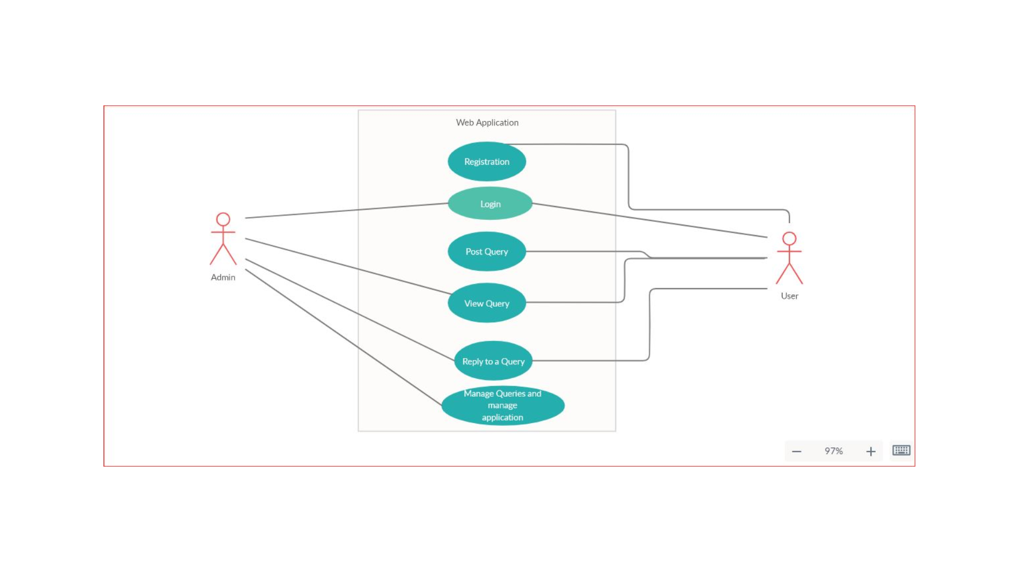

**A use case diagram at its simplest is a representation of a user's interaction with the system that shows the relationship between the user and the different** [**use cases**](https://en.wikipedia.org/wiki/Use_case) **in which the user is involved. A use case diagram can identify the different types of users of a system and the different use cases and will often be accompanied by other types of diagrams as well. The use cases are represented by either circles or ellipses.**

**2.CLASS DIAGRAM**

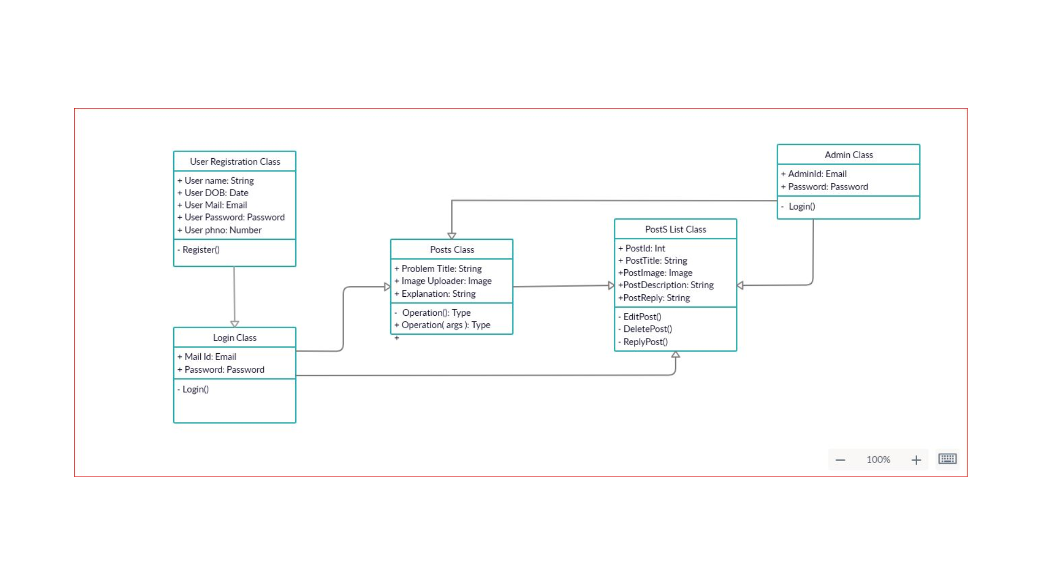

**class diagram in the** [**Unified Modeling Language**](https://en.wikipedia.org/wiki/Unified_Modeling_Language) **(UML) is a type of static structure diagram that describes the structure of a system by showing the system's** [**classes**](https://en.wikipedia.org/wiki/Class_(computer_science))**, their attributes, operations (or methods), and the relationships among objects.**

**3.SEQUENCE DIAGRAM**

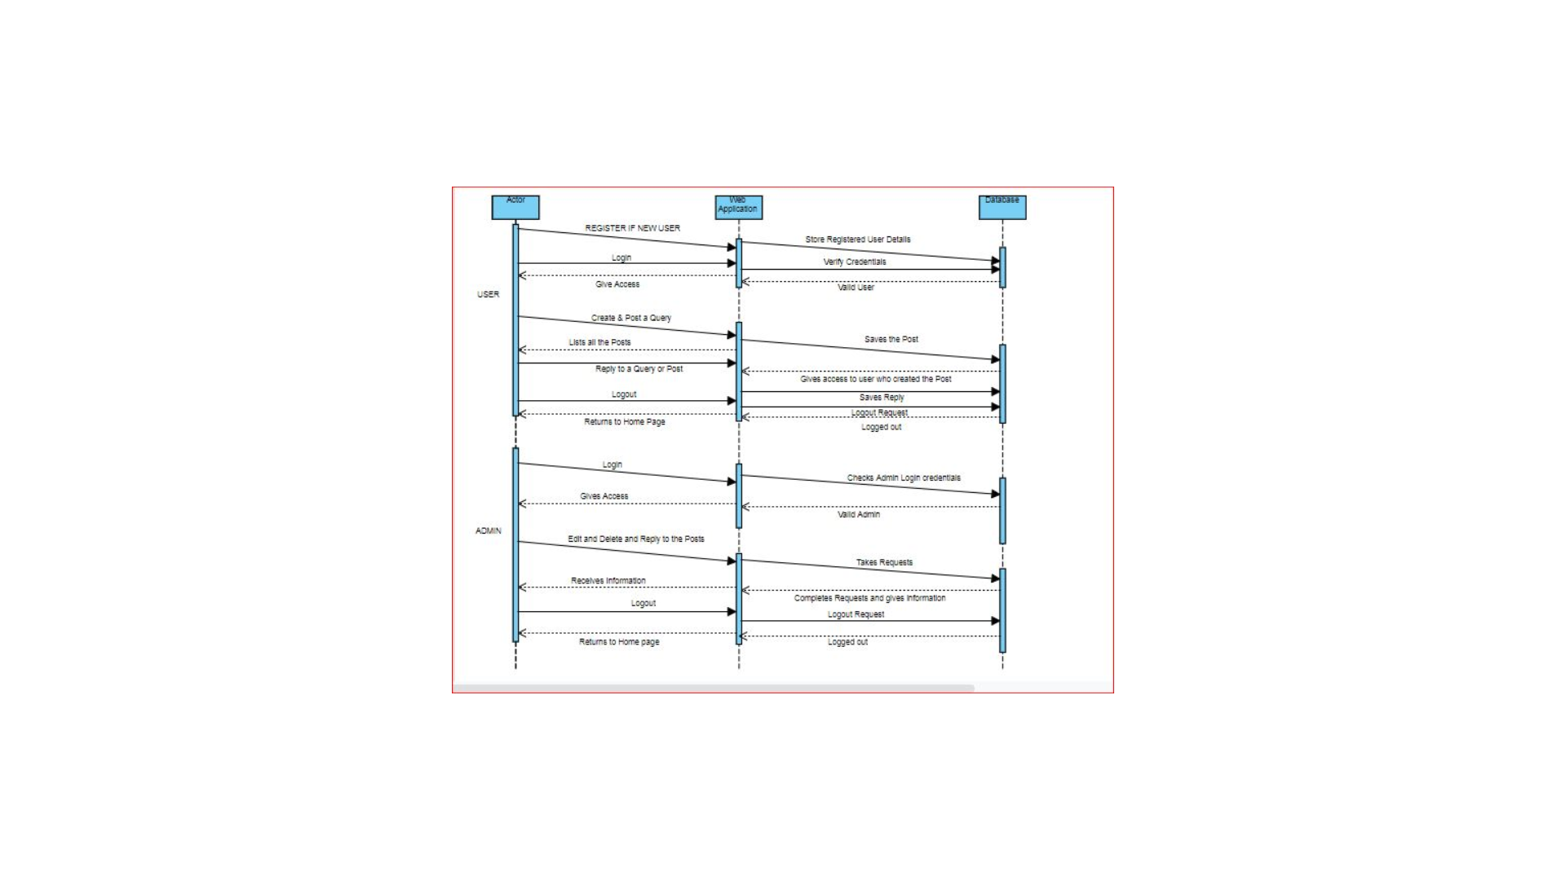

**A sequence diagram shows object interactions arranged in time sequence. It depicts the objects and classes involved in the scenario and the sequence of messages exchanged between the objects needed to carry out the functionality of the scenario.**

**5.IMPLEMENTATION**

Front End:

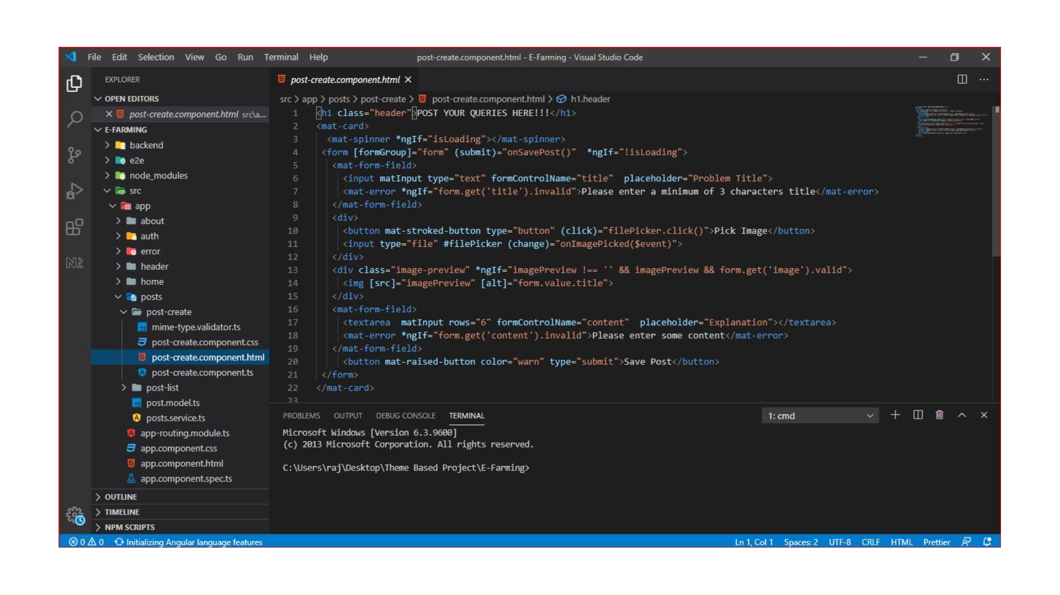

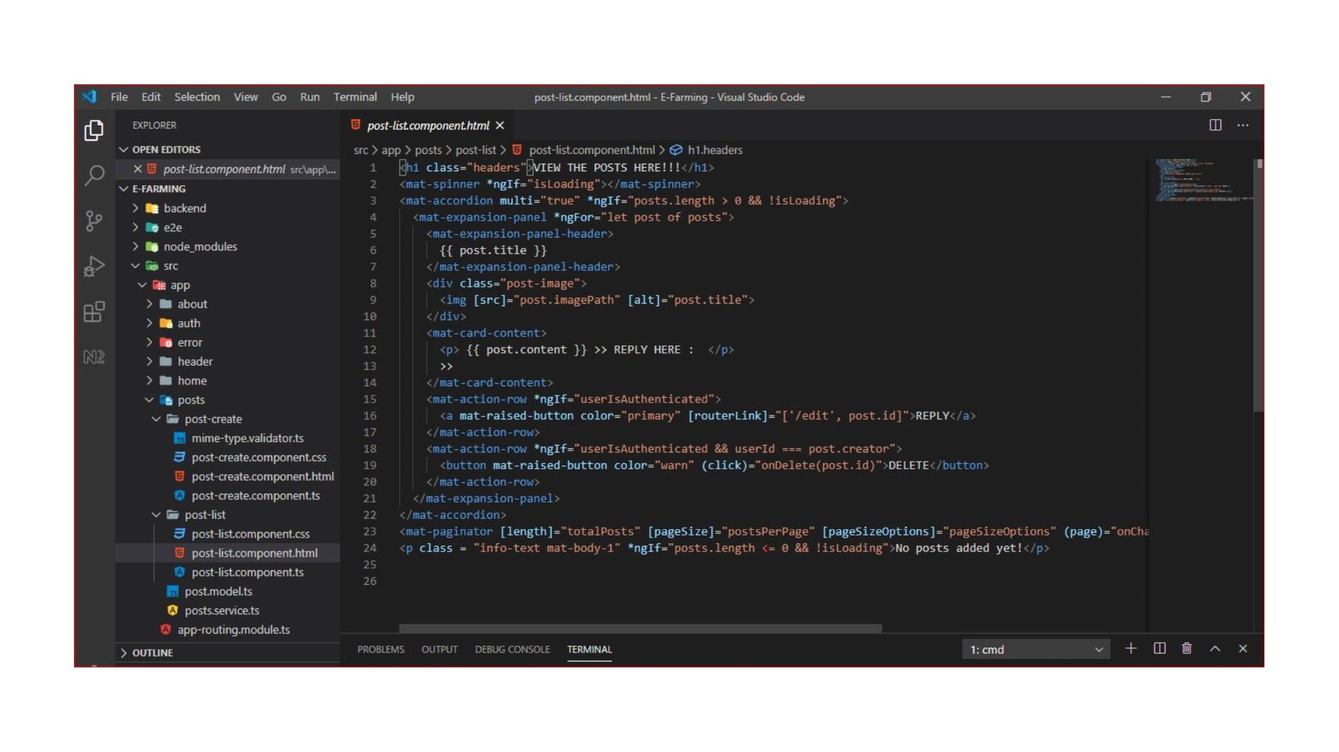

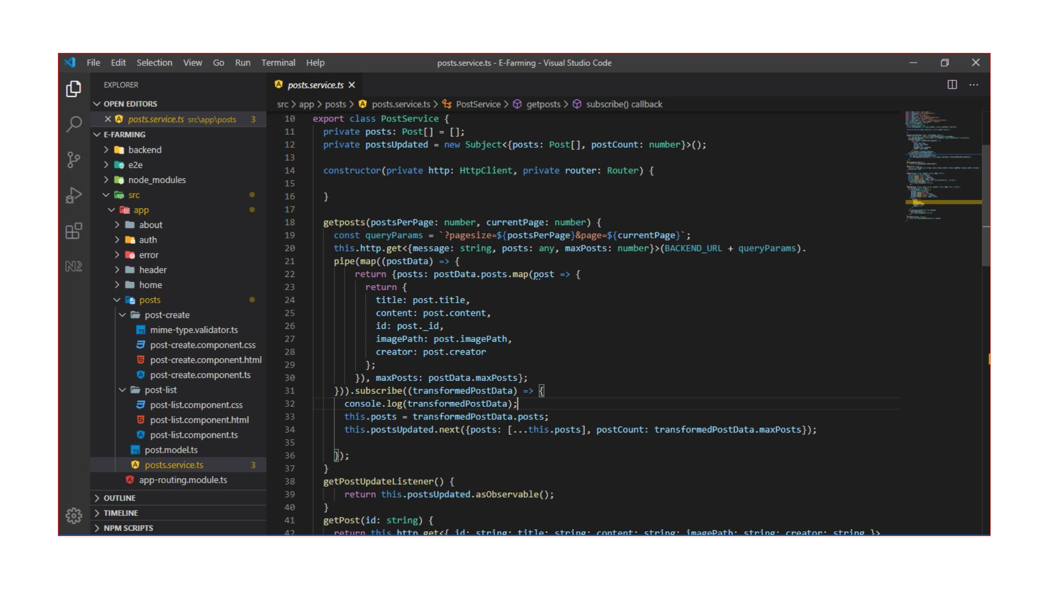

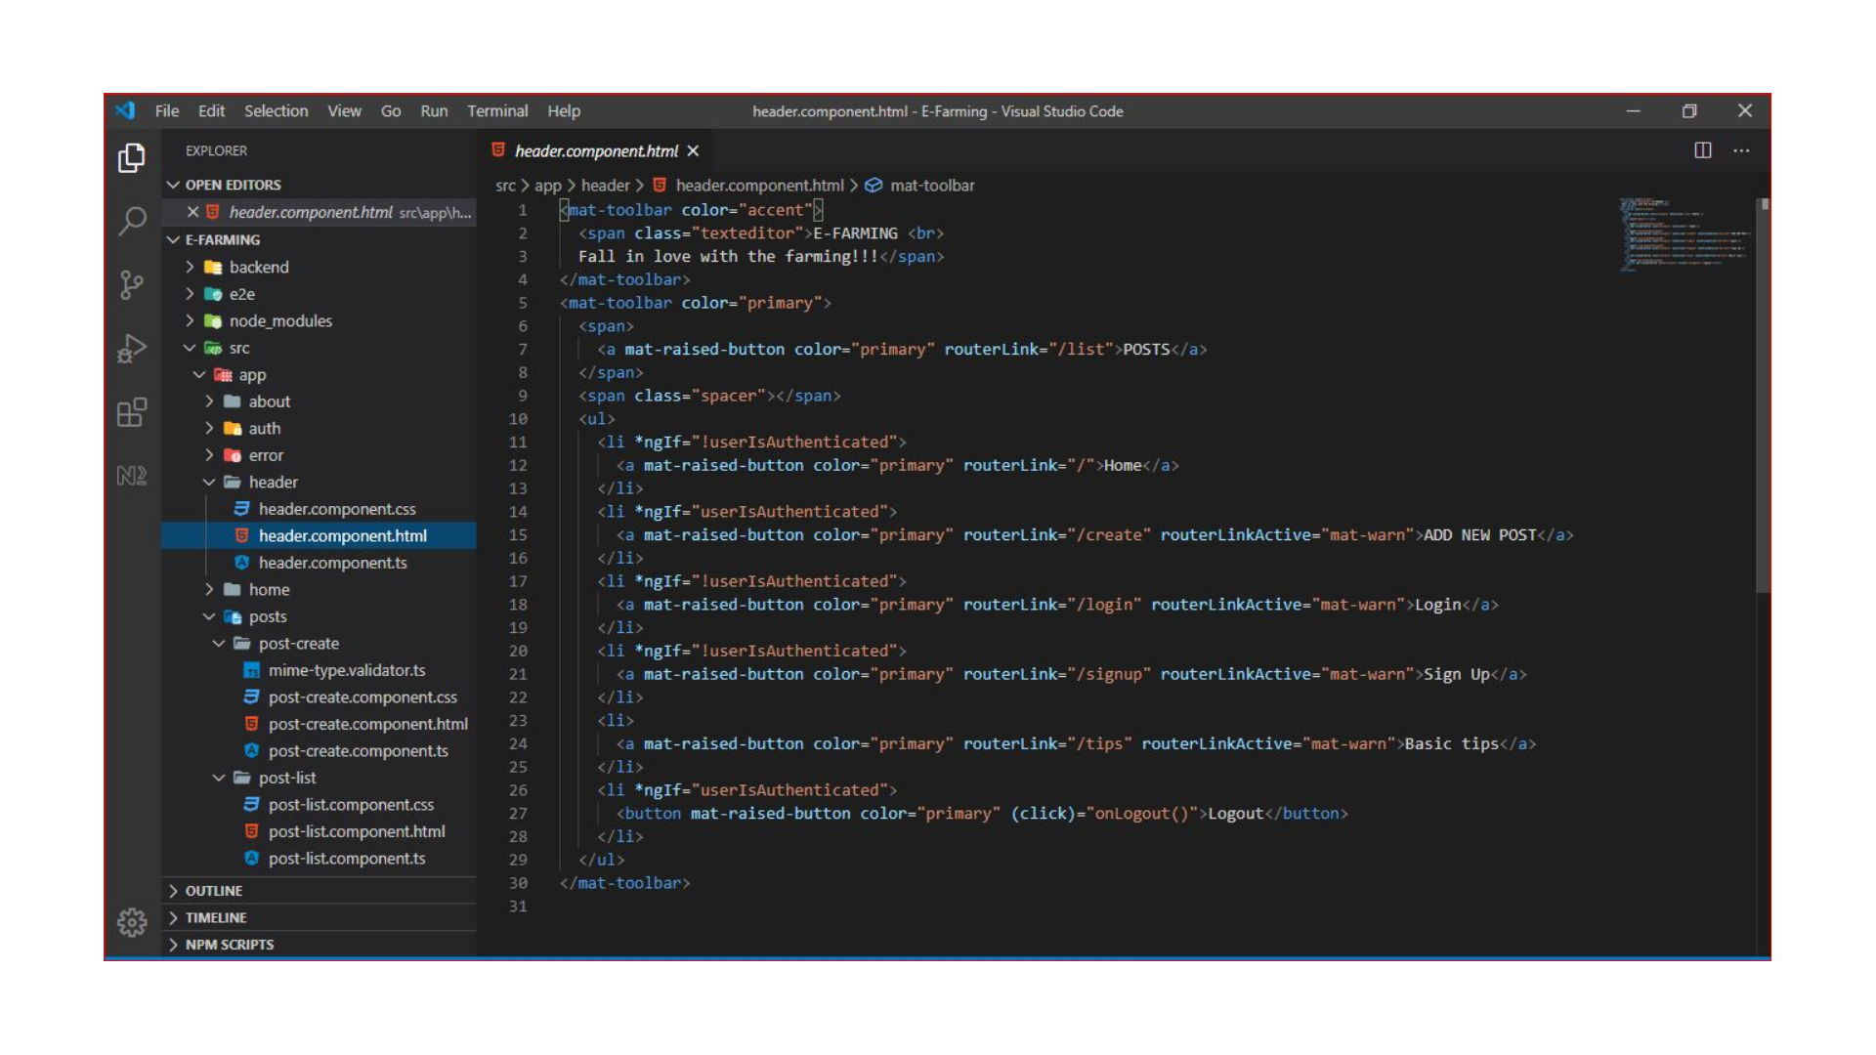

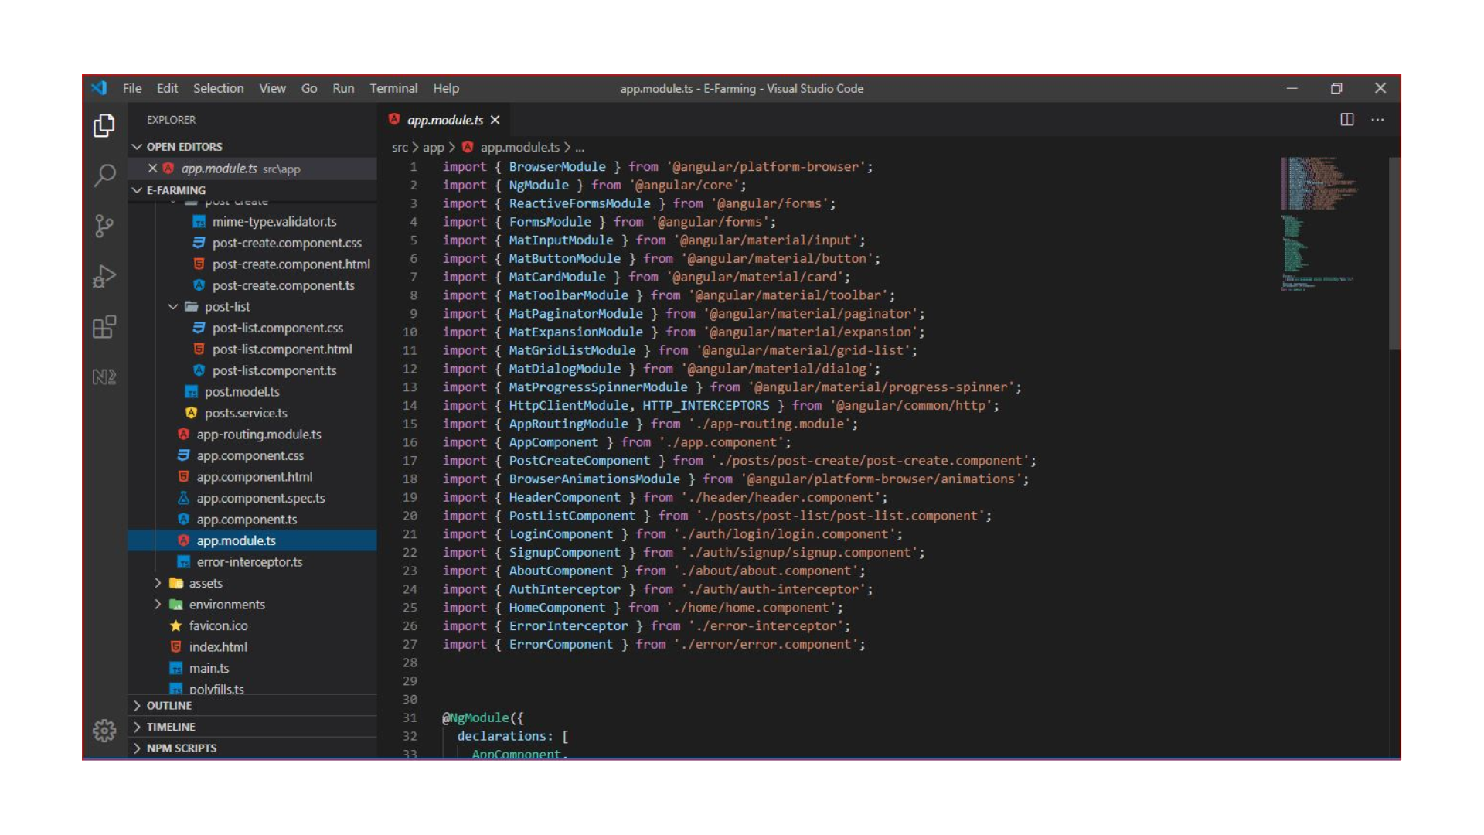

Back End:

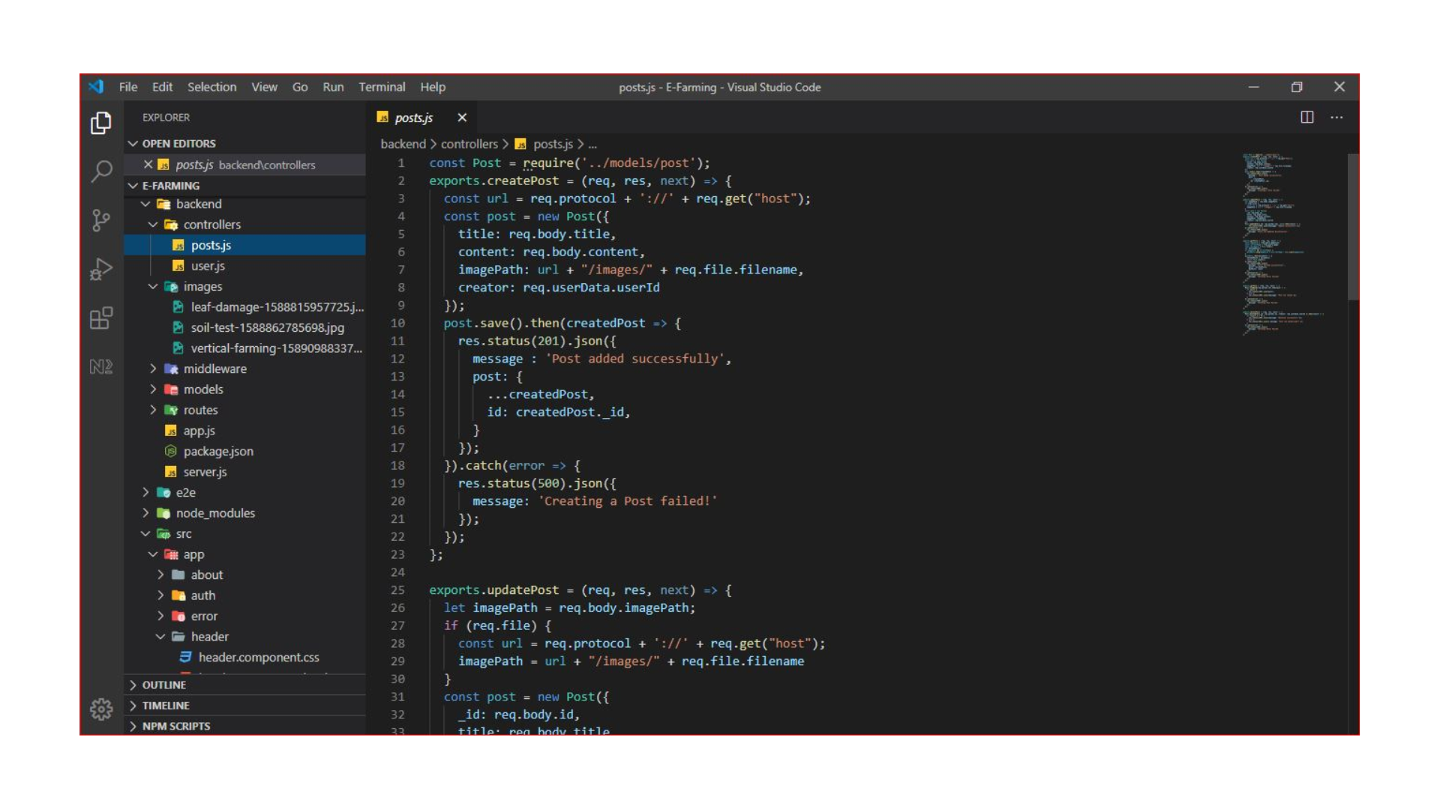

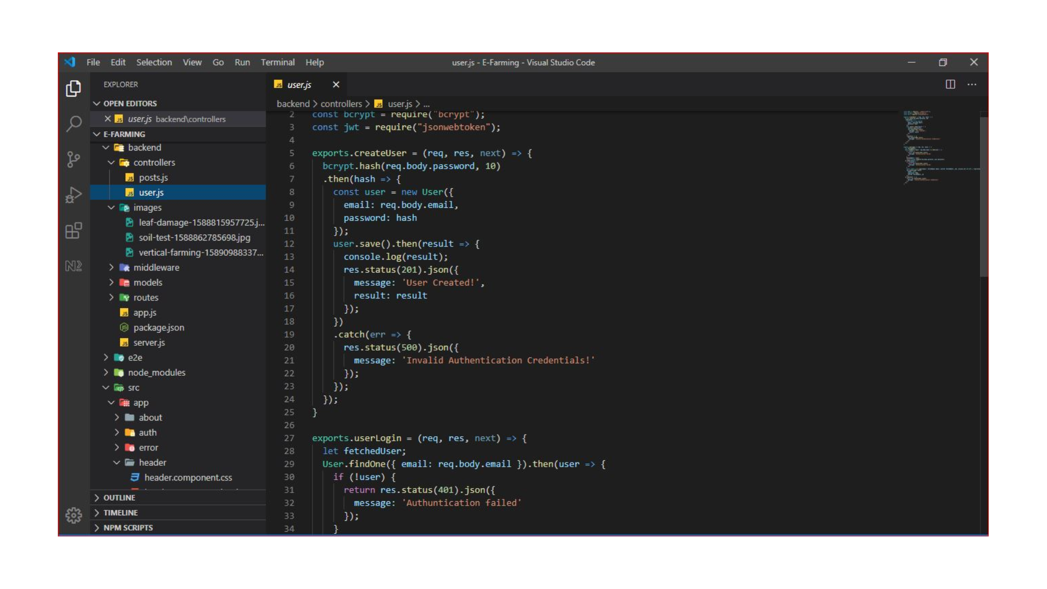

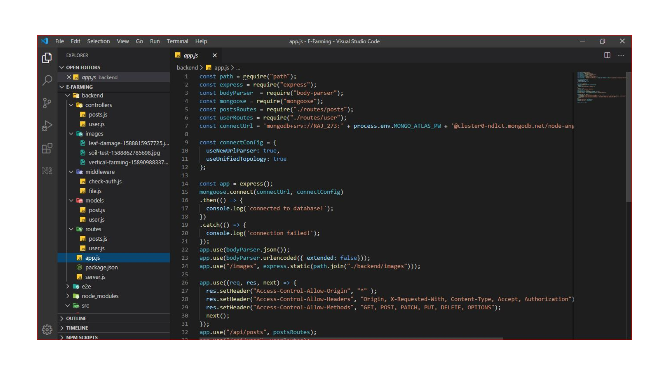

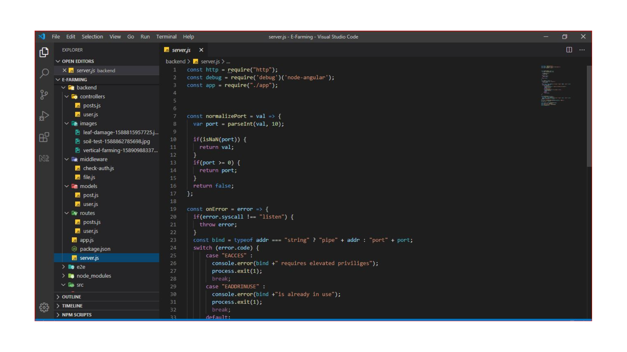

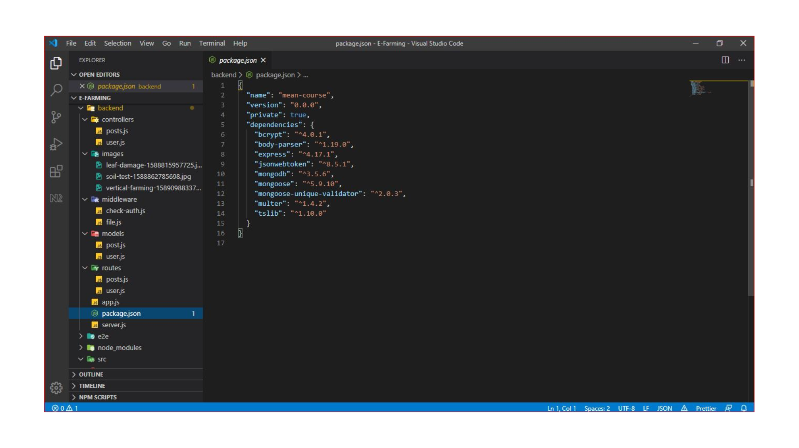

**6.RESULTS**

**Home Page:**

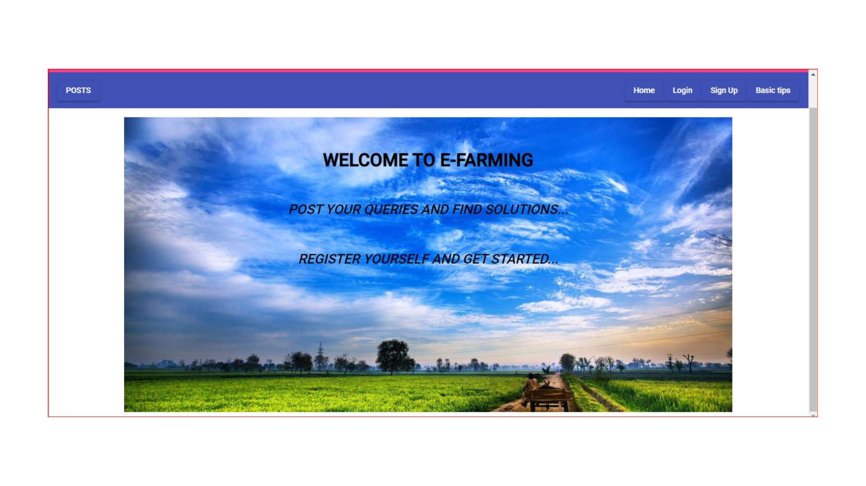

**Sign Up Page**: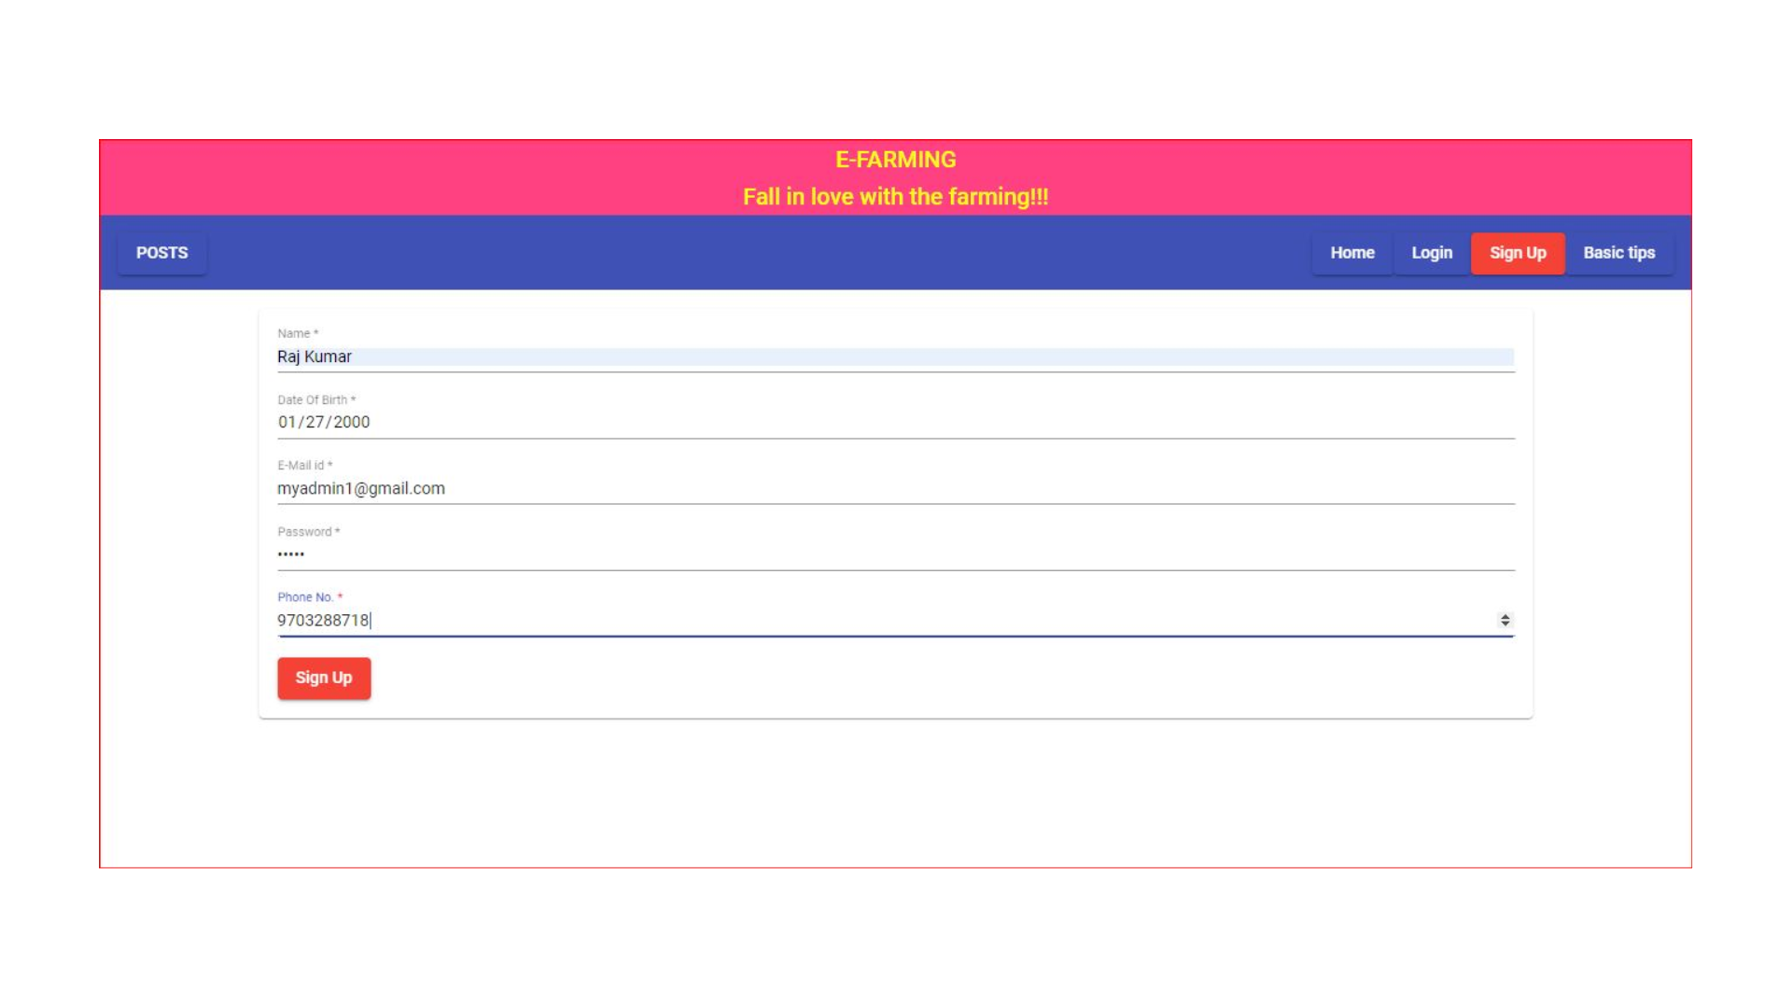

**Login Page:**

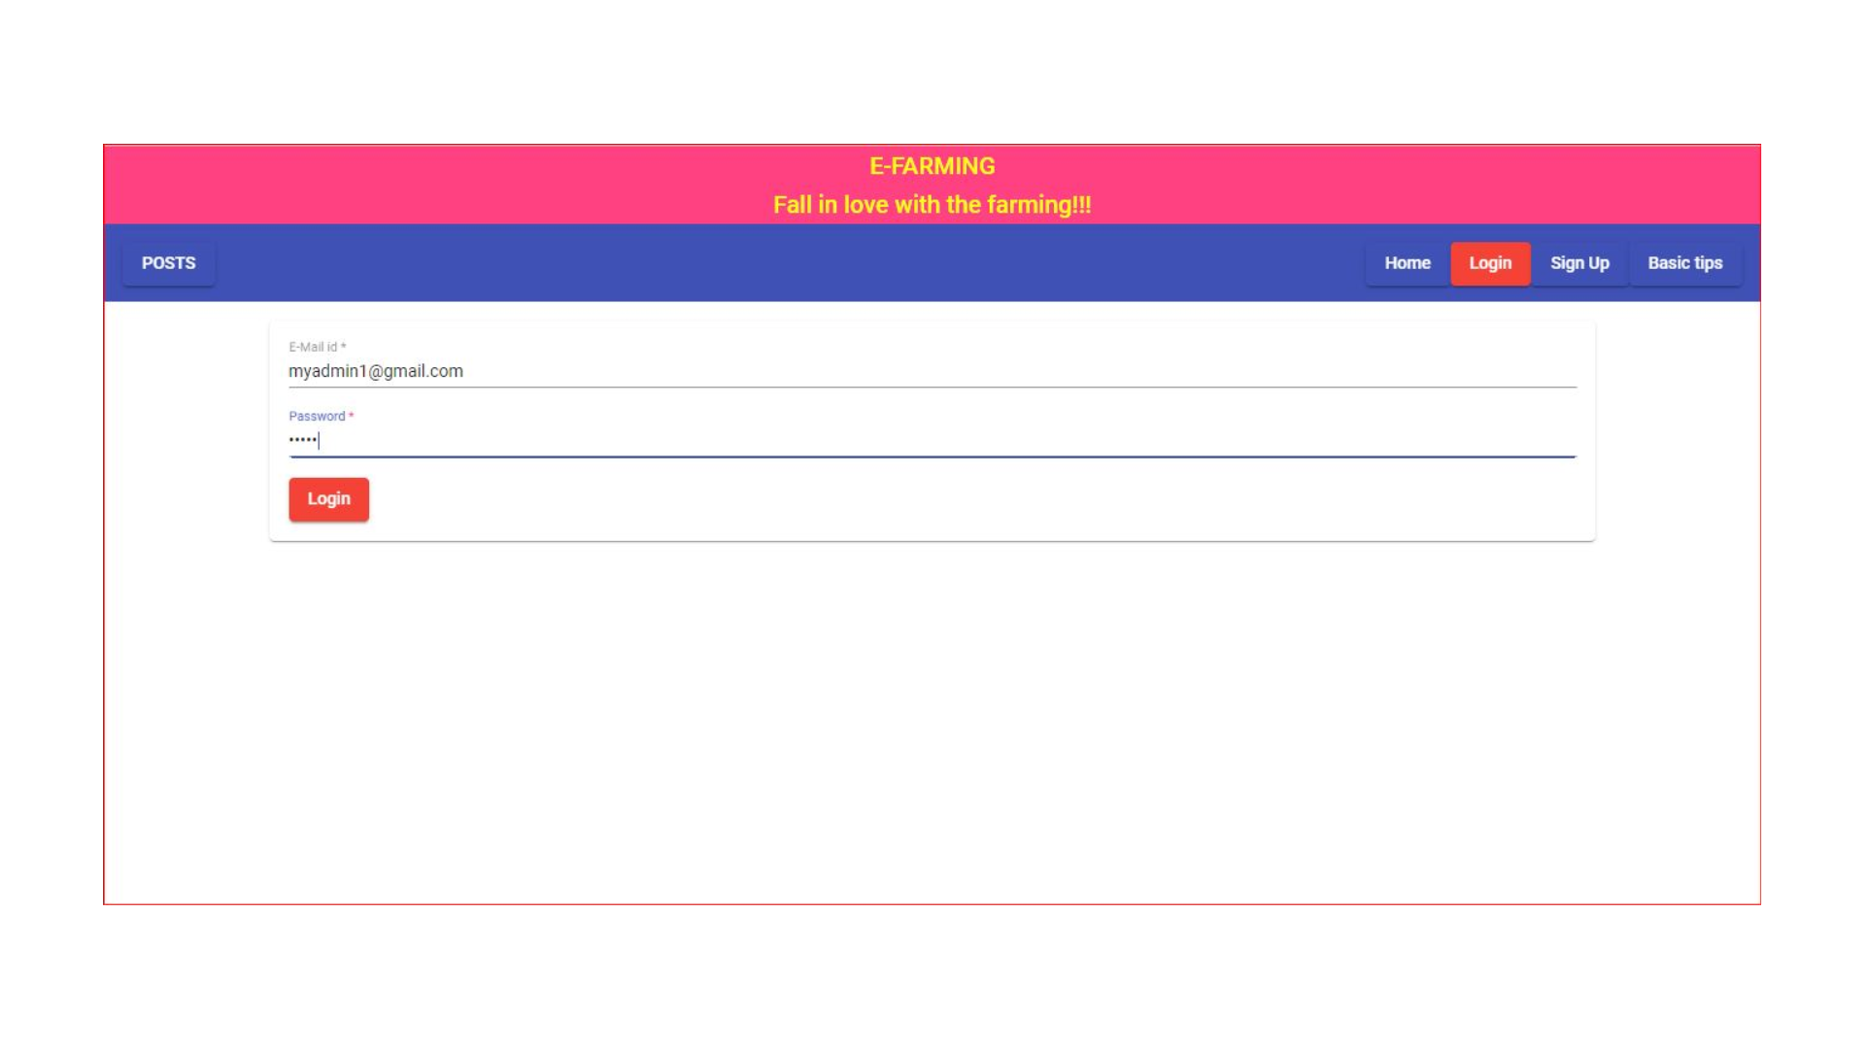

**Creating Post Page:**

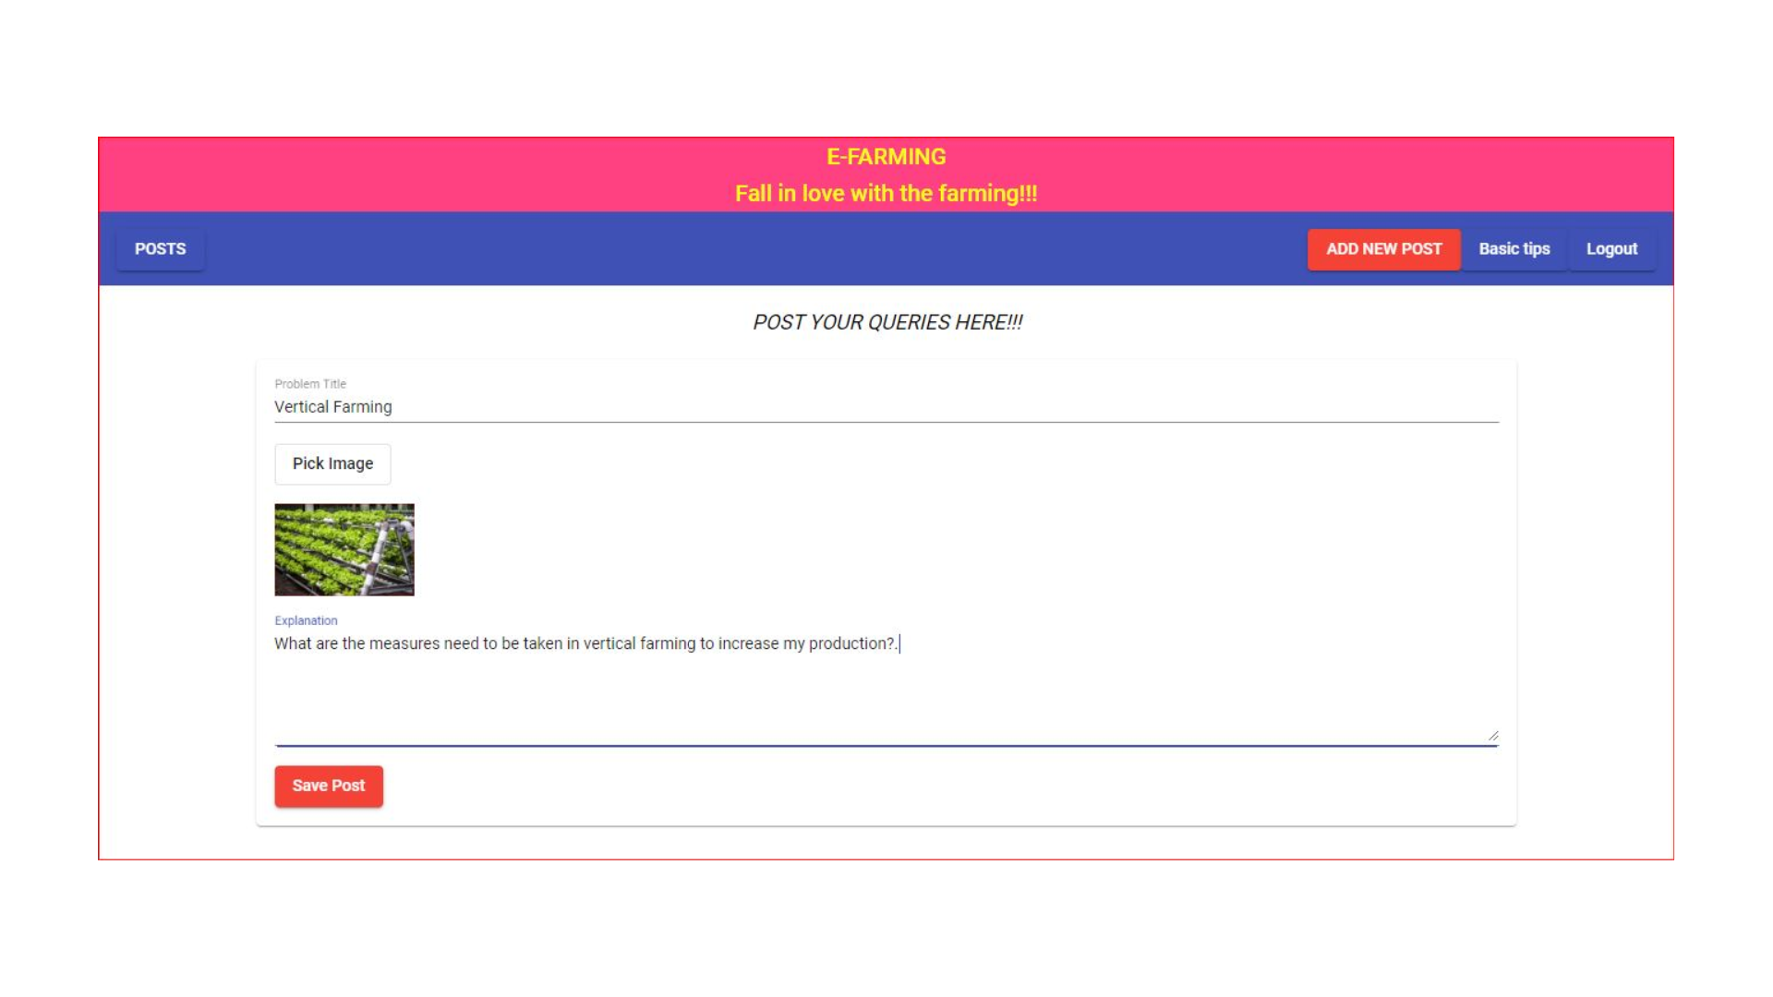

**Reply given to Query:**

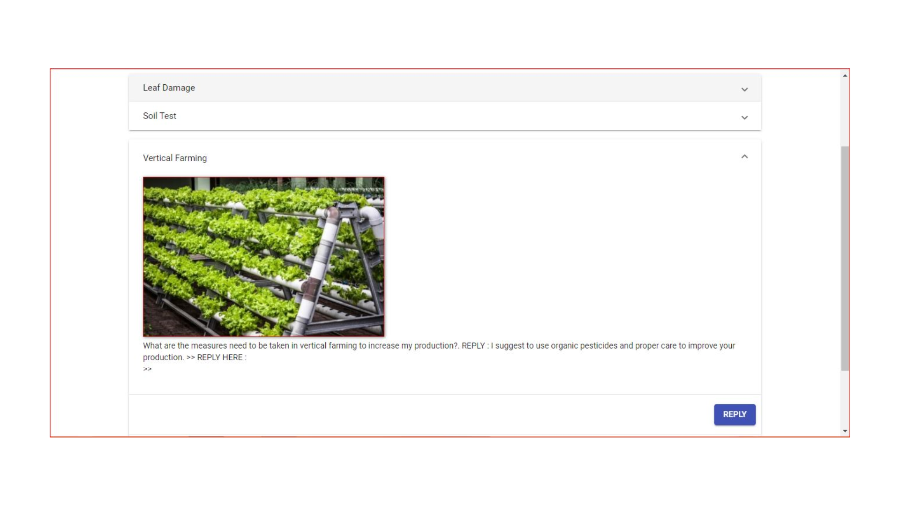

DATA BASE STORAGE

MongoDB Data Base:

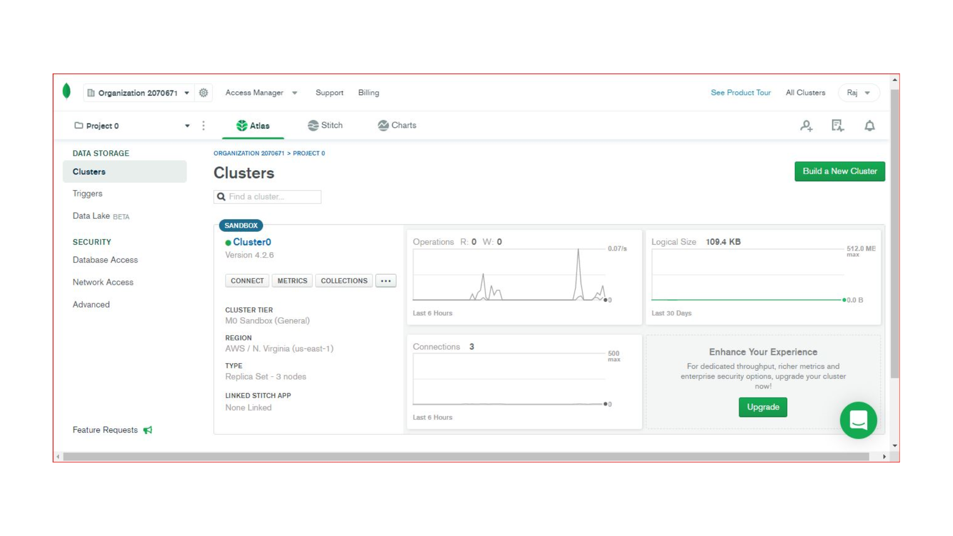

All the Posts Data in MongoDB Database:

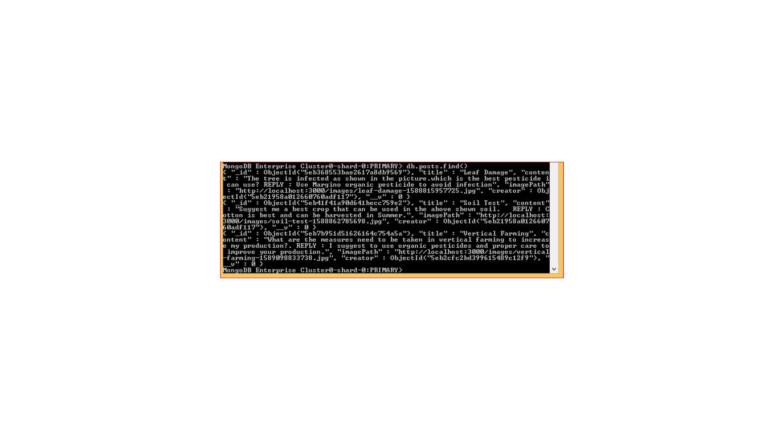

BASIC TIPS PAGE:

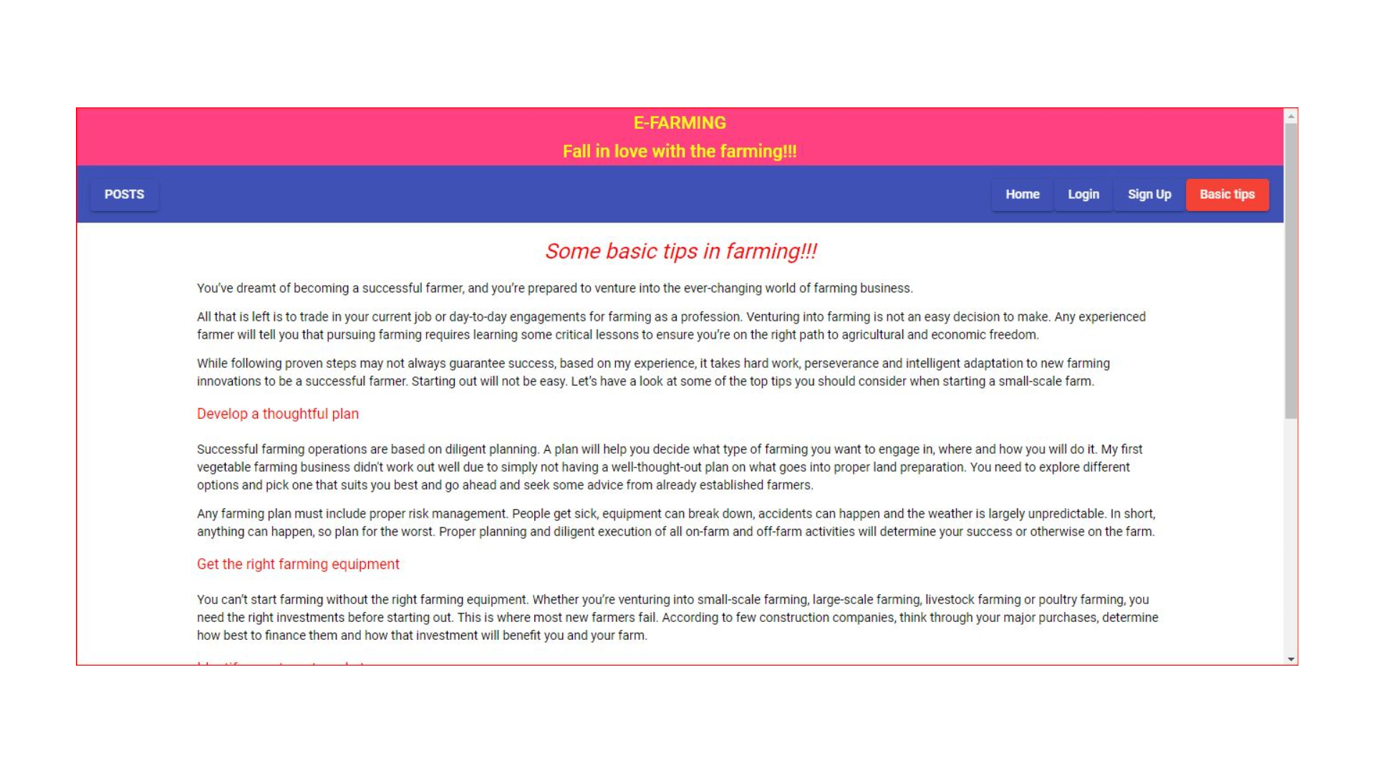

Viewing Posts Without Logging in but cannot access them…

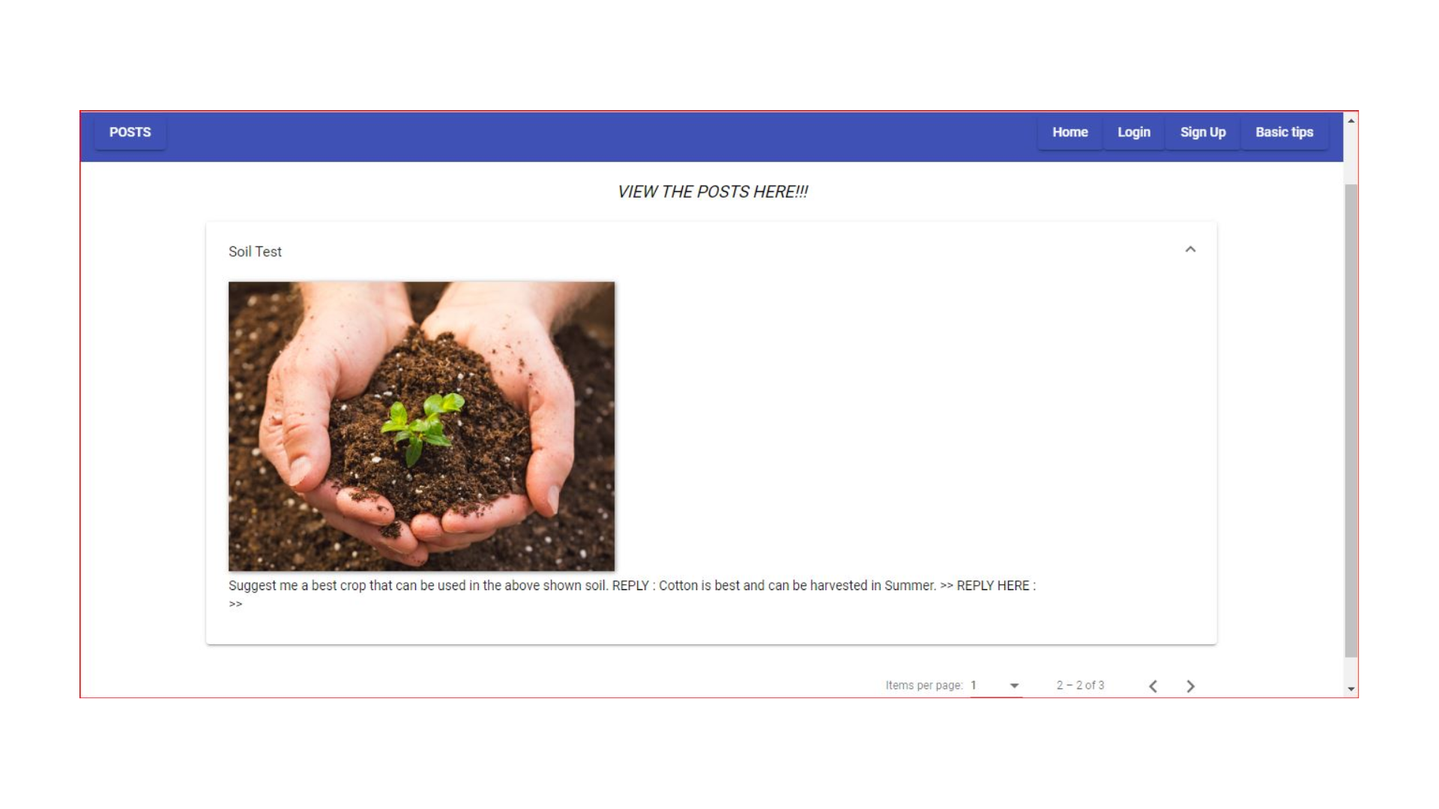

Can Edit and Delete our Own Post:

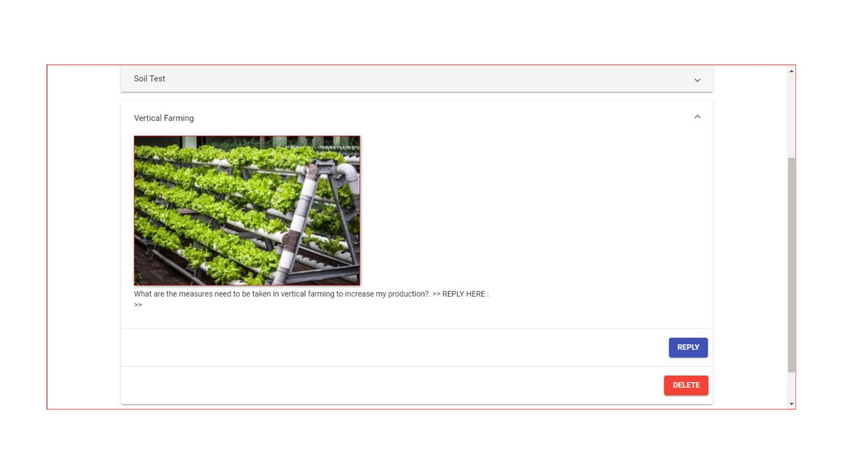

Can reply to other’s Posts…

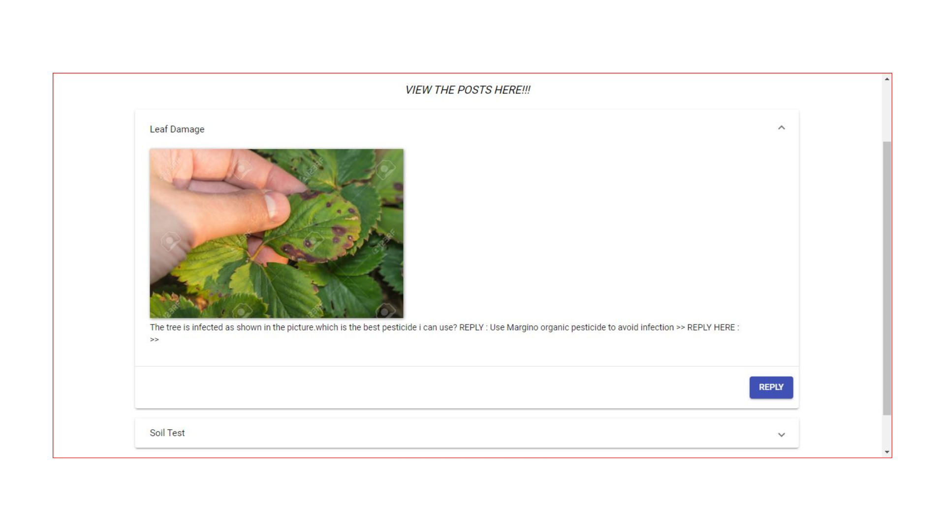

Image Stored in Backend

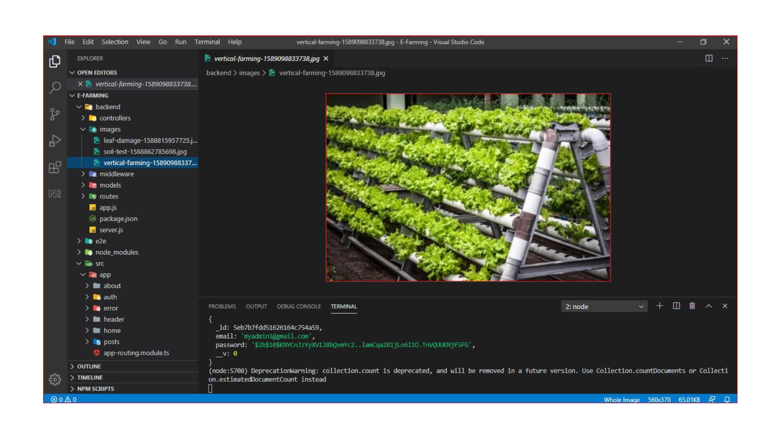

LOGOUT and Redirected to Home page

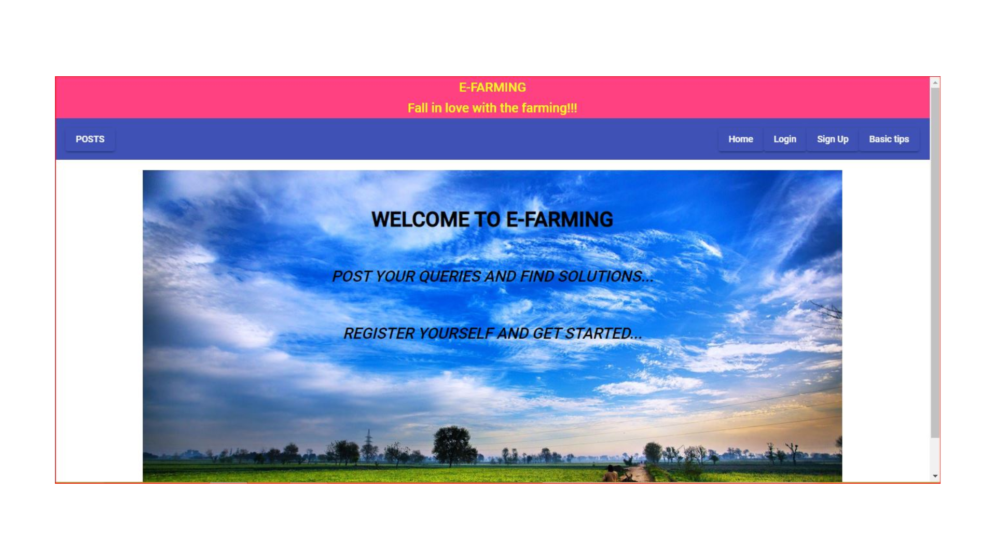

**6.TESTING**

Validations are performed on passwords, posts. Passwords are validated using password

hashing algorithm.And posts are validated using postid and userAuthentication methods.

**7.CONCLUSION AND FUTURE SCOPE**

**CONCLUSION**

To conclude, E-Farming is great platform for the farmers to perform agricultural activities effectively than before. It keeps farmers more engaged in their work. Through this application I think many Indian farmers would be able to increase their Agricultural production.

If this will be successful, we are also trying to add lot of improvements to this Web Application. Improvements would be like how to grow animals, the process of bringing them up, feeding them, treating the disease effected animals etc.

**FUTURE SCOPE**

* As of now this application is only restricted to the growth of crops and things related to crops.
* In future we are also trying to focus on the growth and things related to domestic animals which live both on and off the field.
* We are trying to add more modules to our application to get precise information about the growth of crops.

**8.REFERENCES**

> https://www.udemy.com/

> https://material.angular.io/

> https://nodejs.org/en/docs/

> https://docs.mongodb.com/cloud/